Abdullah Ghani 19F-0909

Zain Ul Abideen 19F-0915

Mahnoor 19F-0965

SE-4A

Lab 06

# Actor:

* Customer
* Admin
* Drivers

# Use cases:

|  |  |
| --- | --- |
| **High level** | **Extended** |
| * Sign up. * View available cars. * Give feedback. * Admin login * View feedback. * Track cars. | * Manage cars. * Manage drivers. * Rent car. * Ride. * Payment method. * Self-drive. |

# High Level use Cases:

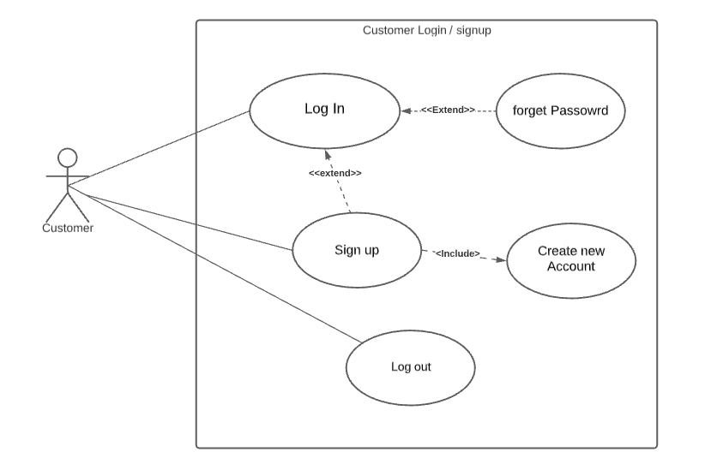

|  |  |
| --- | --- |
| **Use Case:** | Sign Up/Login |
| **Actors:** | Customer |
| **Type:** | Primary |
| **Description:** | Customer shall open the app in client server and is asked to login with his credentials. If customer has already set up his account, he enters his credentials and logs in. If he shall forget his password, he clicks forget password. If he shall not have an account, he shall signs up to create an new one. |

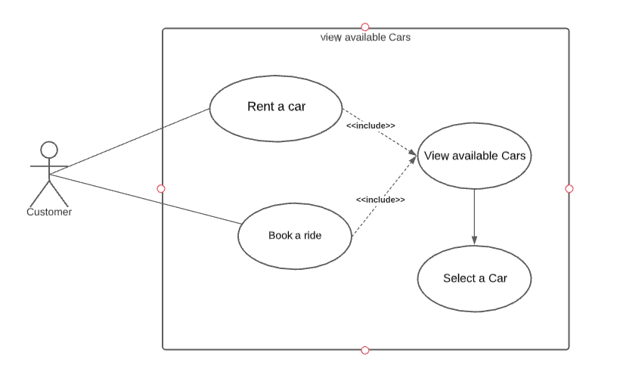

|  |  |
| --- | --- |
| **Use Case:** | View available cars |
| **Actors:** | Customer |
| **Type:** | Primary |
| **Description:** | While renting a car or booking a car for a ride, customer shall look for available cars and shall select one to rent or for booking it for a ride. |

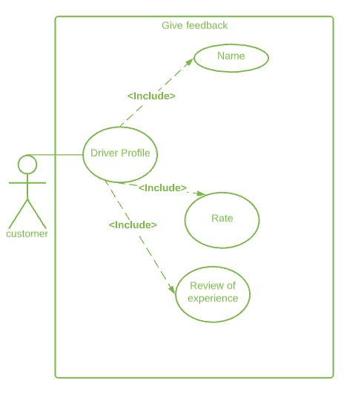

|  |  |
| --- | --- |
| **Use Case:** | Give feedback |
| **Actors:** | Customer |
| **Type:** | Primary |
| **Description:** | When the customer have finished there ride they shall receive feedback portal, the customer rates the over-all experience of ride or rental car out of five(5) stars. The customer shall also be able to describe their experience in a review by giving constructive criticism or positive review. |

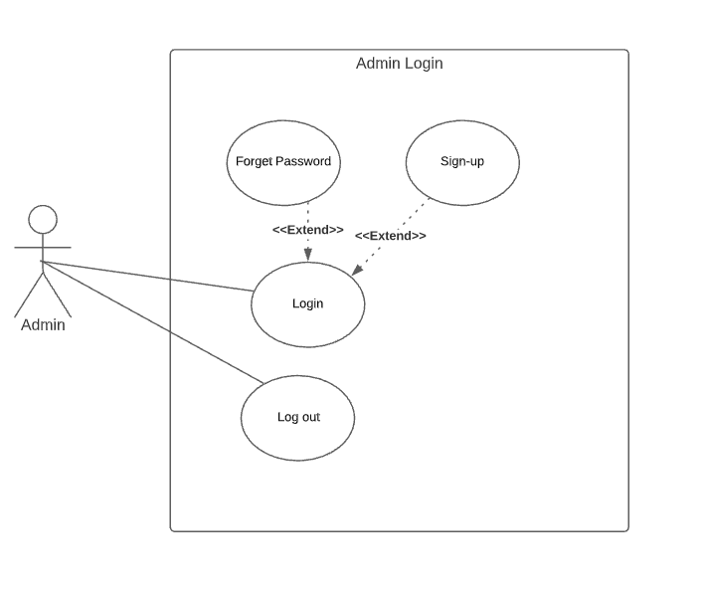

|  |  |
| --- | --- |
| **Use Case:** | Admin Login |
| **Actors:** | Admin |
| **Type:** | Primary |
| **Description:** | Admin opens the app in administration server and shall be asked to login with his credentials. Admin shall already set up his account he enters his credentials and logs in. If he shall forgot his password, he clicks forgets password. If he shall not have an account he signs up. He shall then also log out. |

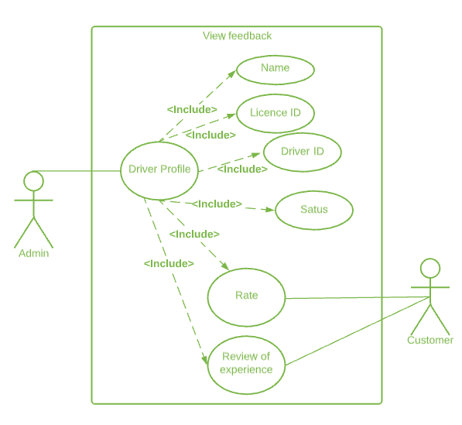

|  |  |
| --- | --- |
| **Use Case:** | View feedback |
| **Actors:** | Admin, Customer |
| **Type:** | Secondary |
| **Description:** | When the customer has finished their ride, they shall give review. The admin receives it along with the driver’s profile to keep check and balance. The customer shall view their history of reviews on drivers too. |

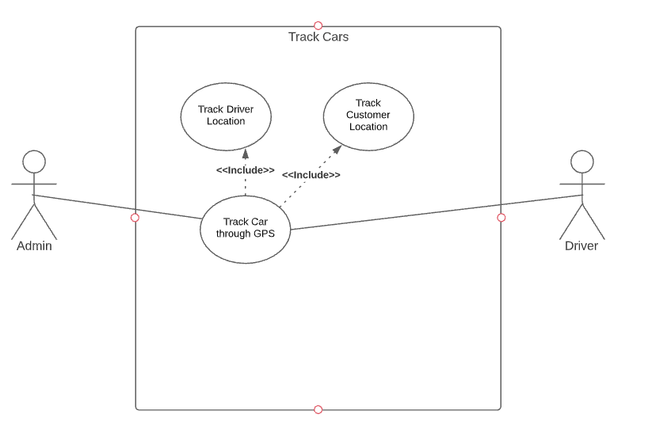

|  |  |
| --- | --- |
| **Use Case:** | Track Cars |
| **Actors:** | Admin, Driver |
| **Type:** | Primary |
| **Description:** | Admin and driver both shall track the location of the car. Admin shall also track the location of the driver from his cell phone and they shall also track the location of the customer to see where they shall pick them from. |

# Expanded Use cases:

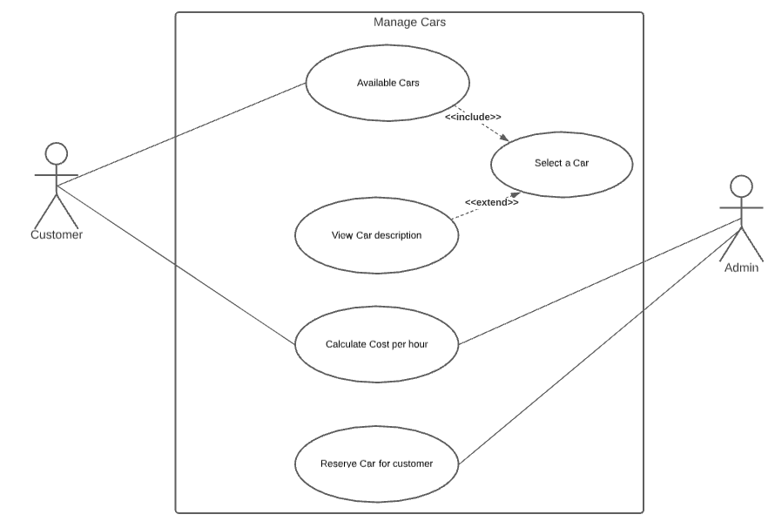

|  |  |
| --- | --- |
| **Use Case:** | Manage Cars |
| **ID:** | 001 |
| **Description:** | Customer shall see the description of a selected car and shall get an estimate cost after calculating the price of rent per hour of that vehicle. |
| **Primary Actors:** | Customer |
| **Secondary Actors:** | Admin |
| **Pre-Conditions:** | The Customer has used the service beforehand. |
| **Main flow:** | 1. Customer shall select a car from available cars. 2. Customer shall see the description and details of that car. 3. If the customer wants to rent that car, he shall select the time for keeping the rented car. 4. Admin shall then allot the selected car to that customer. |
| **Post-Conditions:** | Customer shall receive the car and admin receives the payment. |
| **Alternate flow:** | Admin shall not receive the payment and the car shall not be delivered to the customer. |

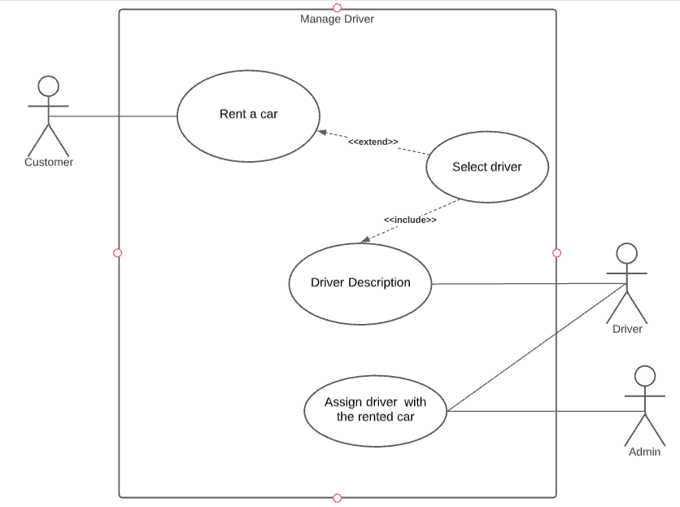

|  |  |
| --- | --- |
| **Use Case:** | Manage Driver |
| **ID:** | 002 |
| **Description:** | Customer shall select a driver and see its details. |
| **Primary Actors:** | Customer |
| **Secondary Actors:** | Driver, admin |
| **Pre-Conditions:** | The Driver must have a driving license |
| **Main flow:** | 1. Customer shall chooses to rent a car. 2. Customer shall chooses for taking a driver. 3. Customer shall be given a list of available drivers. 4. Customer selects a driver and checks its description, where he shall see the driver’s personal info, hands-on experience, previous ratings. 5. Admin assigns the selected driver to that customer. |
| **Post-Conditions:** | The customer shall receive the car with a driver. |
| **Alternate flow:** | Drivers shall not be available, customer shall select for self-drive. |

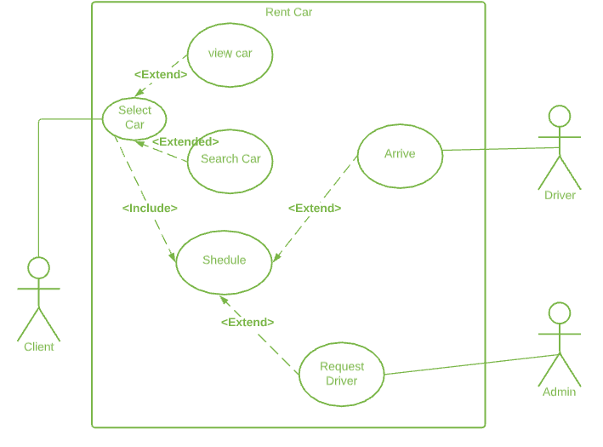

|  |  |
| --- | --- |
| **Use Case:** | Rent car |
| **ID:** | 003 |
| **Description:** | How the customer shall rent a car. |
| **Primary Actors:** | Customer |
| **Secondary Actors:** | Driver, Admin |
| **Pre-Conditions:** | The Customer is logged in the system. |
| **Main flow:** | 1. The customer shall select a car. 2. The customer shall schedule time and location. 3. The customer shall avail the option of requesting for a driver if he likes. 4. The admin shall process the request. 5. The driver shall arrive on the schedule. |
| **Post-Conditions:** | The customer is notified about the confirmed rental request. |
| **Alternate flow:** | * The customer request shall not be confirmed. * The selected car shall not arrive. * The driver shall not arrive on schedule after confirmation. * The admin shall receive complain and arranges appropriate alternative recourses. |

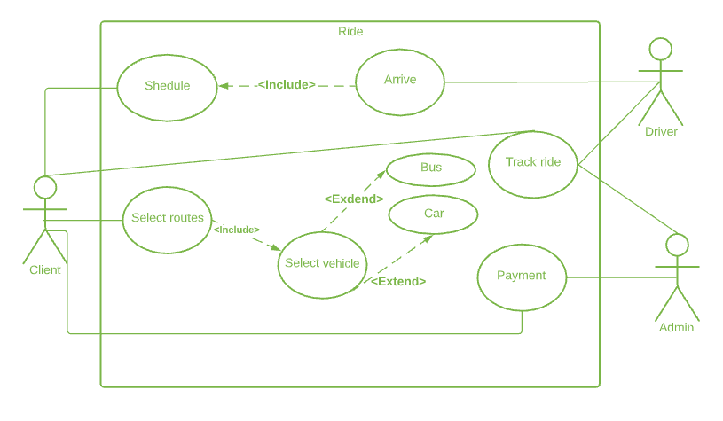

|  |  |
| --- | --- |
| **Use Case:** | Ride |
| **ID:** | 004 |
| **Description:** | How customer shall be able to book a ride |
| **Primary Actors:** | Customer |
| **Secondary Actors:** | Driver, Admin |
| **Pre-Conditions:** | The Customer is logged in the system. |
| **Main flow:** | 1. The customer shall select route. 2. The customer shall schedule including timing and location. 3. The customer shall select vehicle. 4. The customer shall be able to track their ride. 5. The customer shall select payment method. 6. The driver arrive. |
| **Post-Conditions:** | The customer shall be notified about the confirmed rental request. |
| **Alternate flow:** | * The customer request shall not be confirmed. * The driver shall not arrive confirmation. * The customer shall be informed of changes in routes before-hand. |

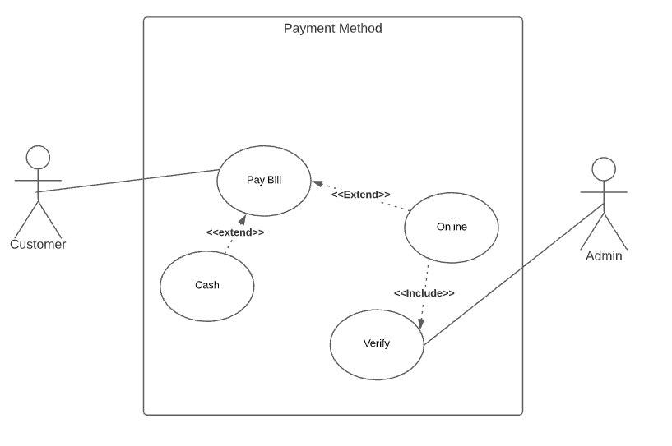

|  |  |
| --- | --- |
| **Use Case:** | Payment Method |
| **ID:** | 005 |
| **Description:** | How the customer shall pay after he has used the service |
| **Primary Actors:** | Customer |
| **Secondary Actors:** | Admin |
| **Pre-Conditions:** | The Customer has used the service beforehand. |
| **Main flow:** | 1. Customer shall choose how he wants to pay Cash or Online 2. If customer selects cash he gives the money to driver. 3. If customer uses Online. He makes the transaction. 4. Then Admin verifies the transaction through the bank |
| **Post-Conditions:** | The payment shall be received and verified. |
| **Alternate flow:** | None |

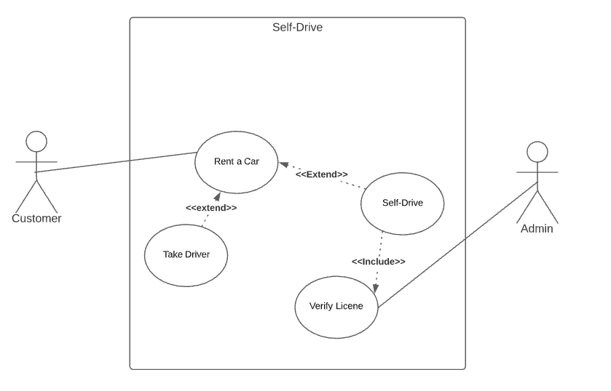

|  |  |
| --- | --- |
| **Use Case:** | Self-drive |
| **ID:** | 006 |
| **Description:** | The procedure customer shall go through if he wants to rent a car and drive it himself. |
| **Primary Actors:** | Customer |
| **Secondary Actors:** | Admin |
| **Pre-Conditions:** | The Customer shall have a driving license. |
| **Main flow:** | 1. Customer Chooses to rent a Car 2. Customer chooses for self-drive over taking a driver 3. Customer Submits his driving license 4. Admin verifies the Driving license. |
| **Post-Conditions:** | The customer shall receive the car and shall return on time specified. |
| **Alternate flow:** | Customer shall not have a driving licence and he shall take a driver. |